**set up a Virtual Private Cloud VPC in AWS cloud to securely host your resources, allowing you to define your own network environment**

**Login to AWS console and go to create VPC**

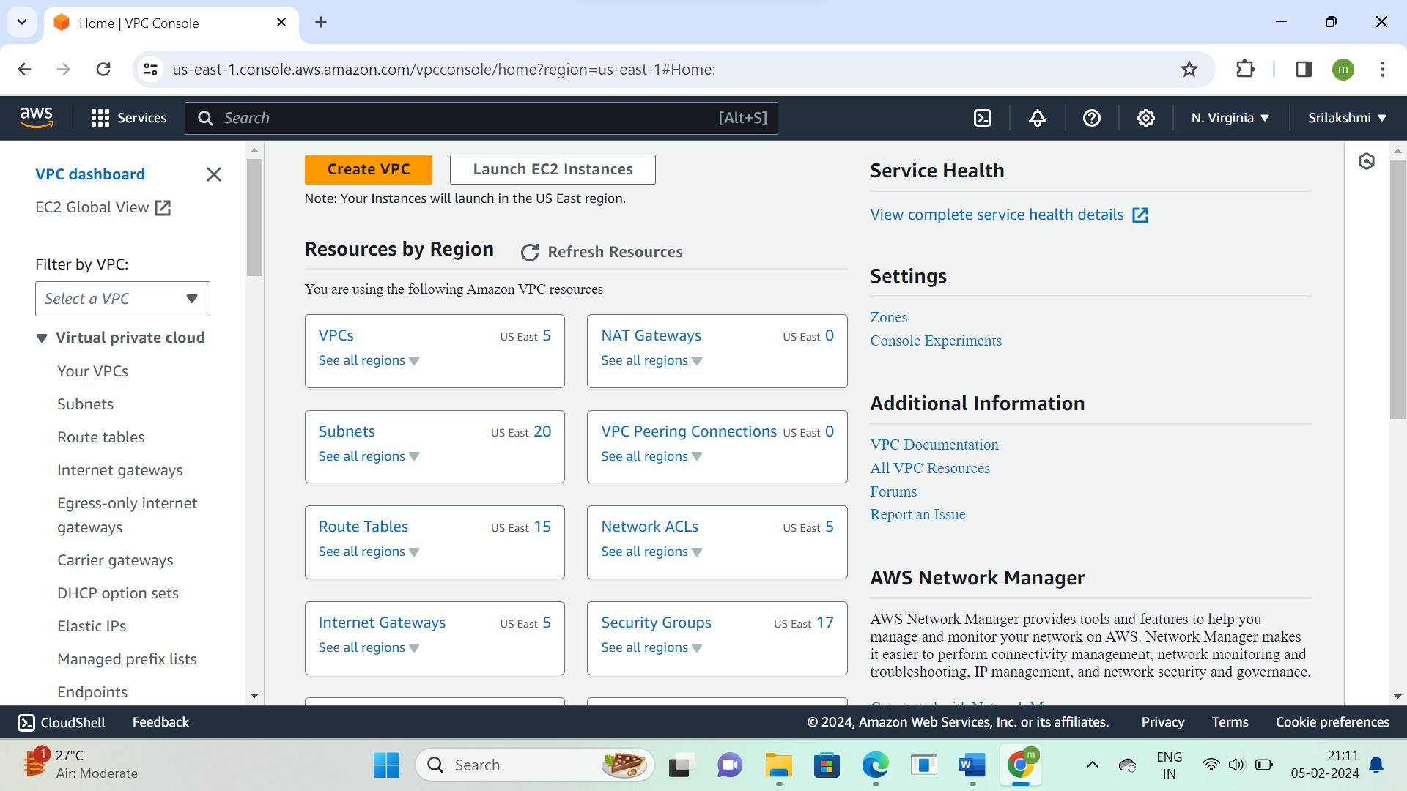

**Name tag-sritask2, IPV4 CIDR block-10.0.0.0/24 and click on create VPC**

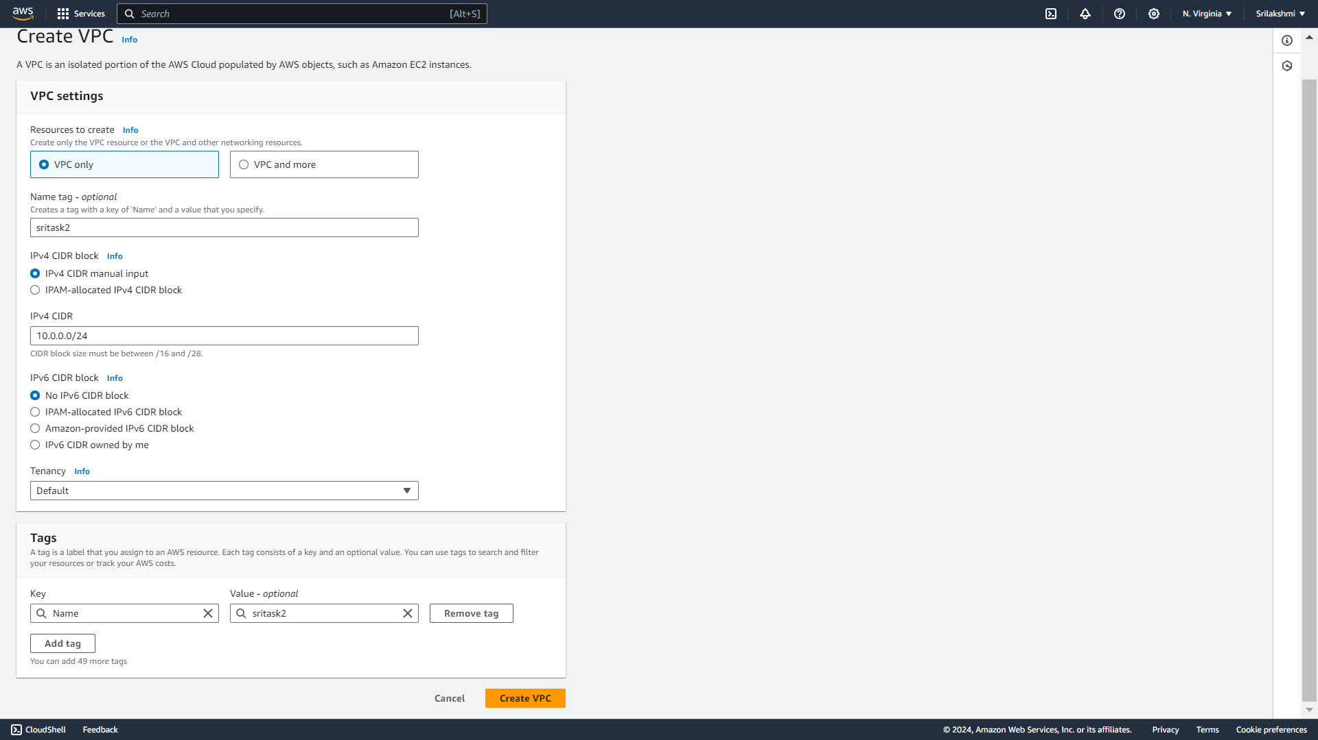

**This is the VPC view**

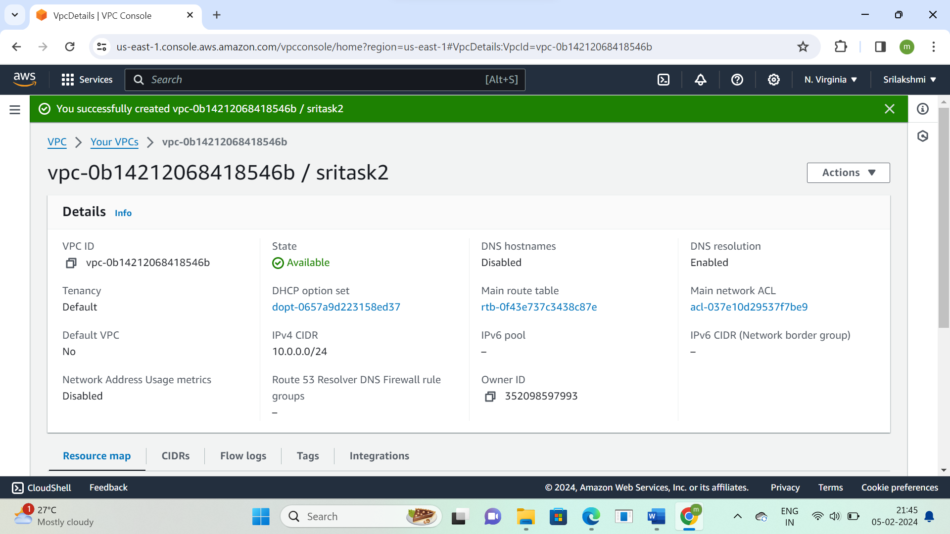

**Create subnet with availability zone and IPV4 subnet-CIDR block**

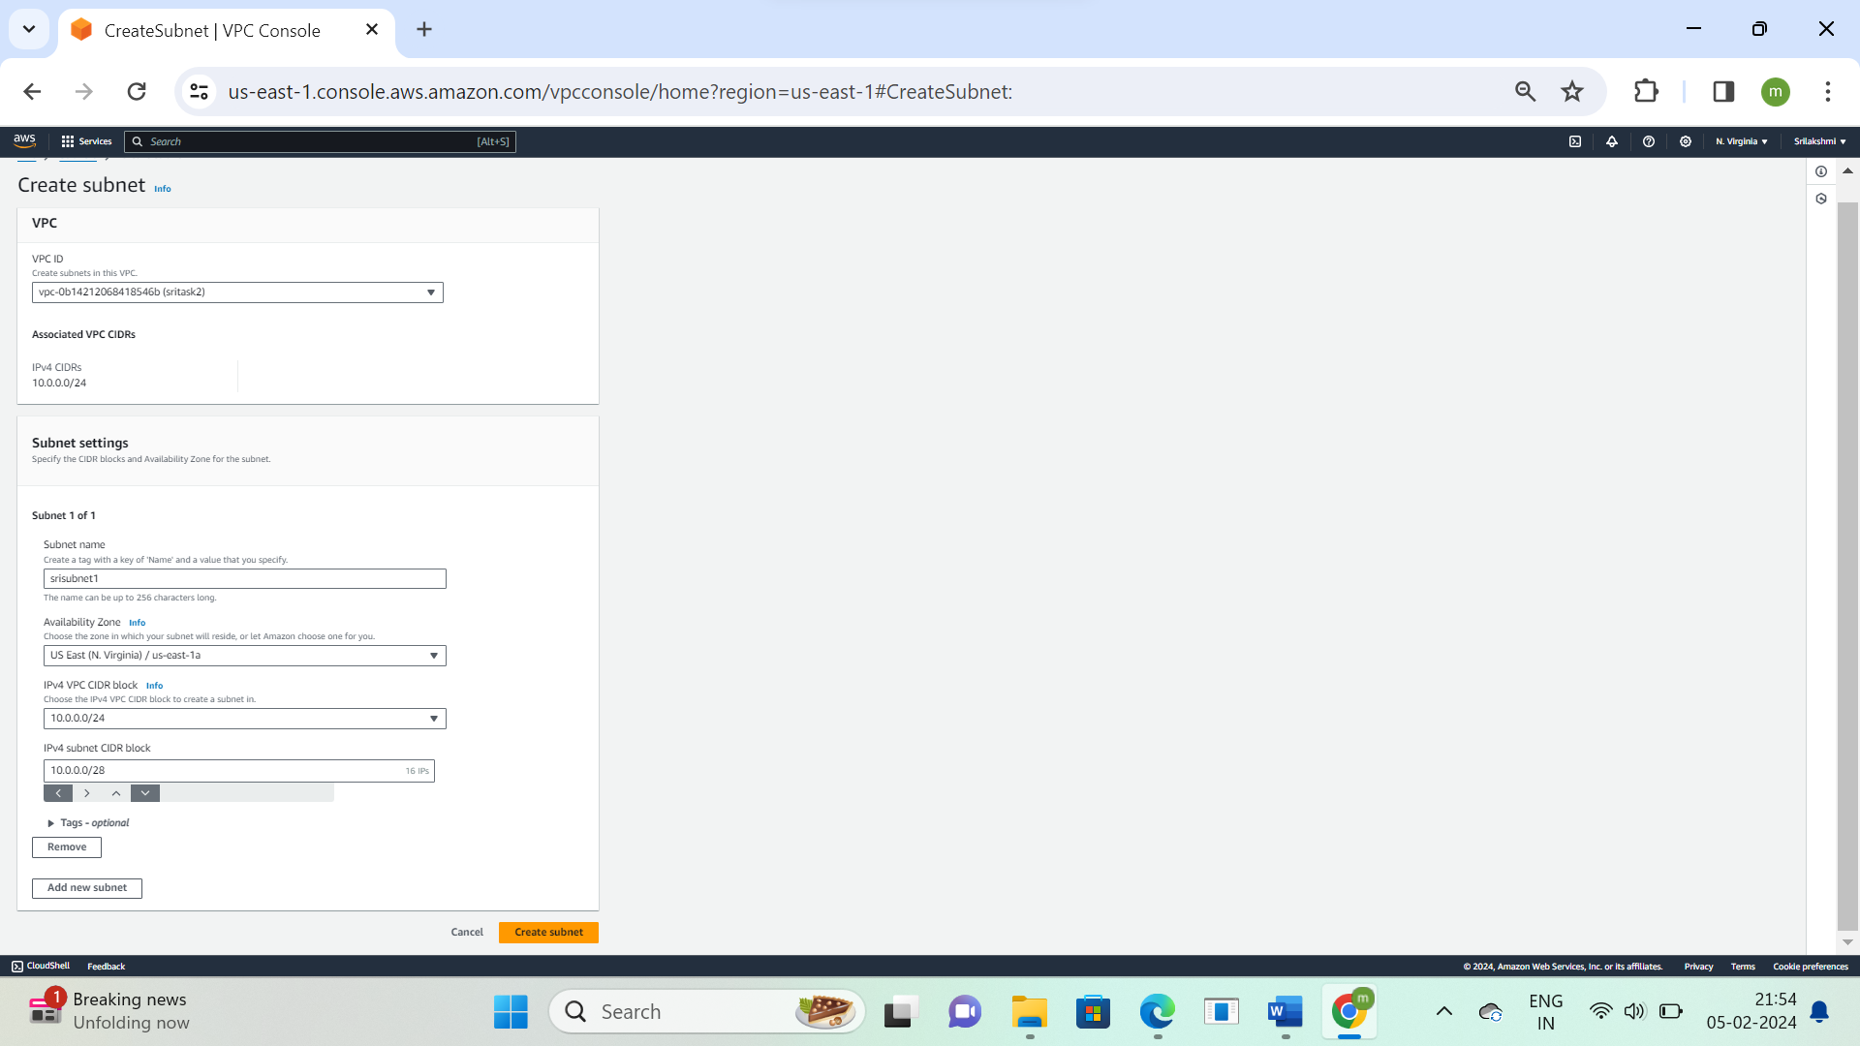

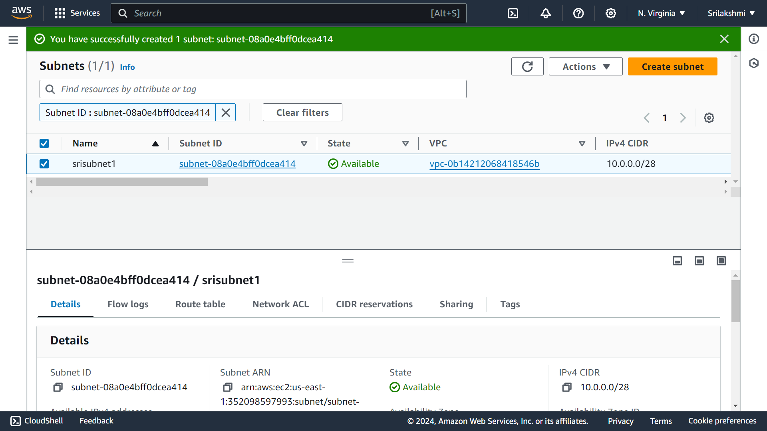

**Create internet gateway, Name-sri-igw**

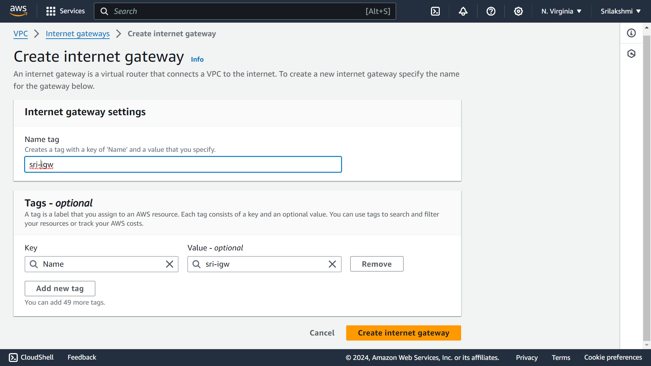

**Click on Attach to VPC**

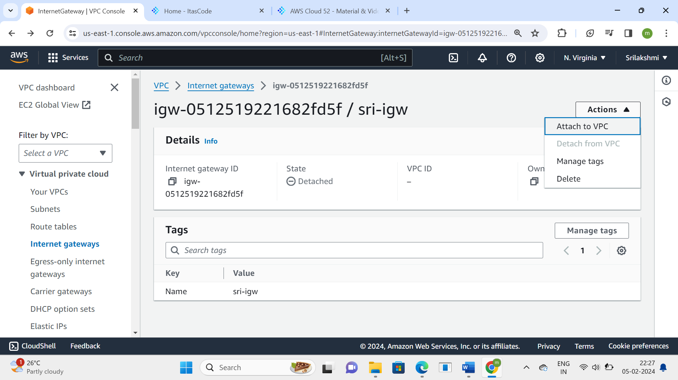

**Attach internet gateway to VPC to get internet access**

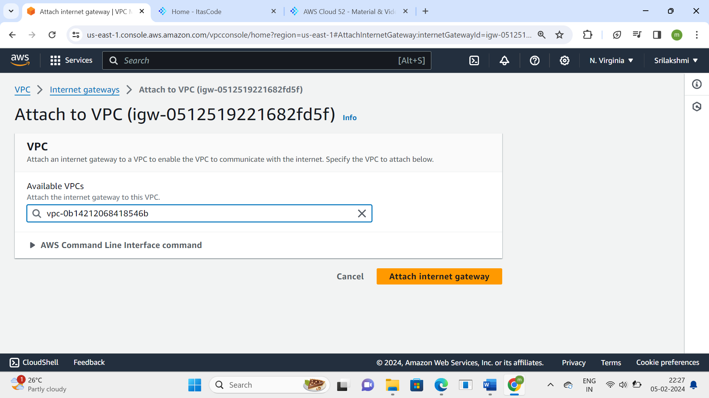

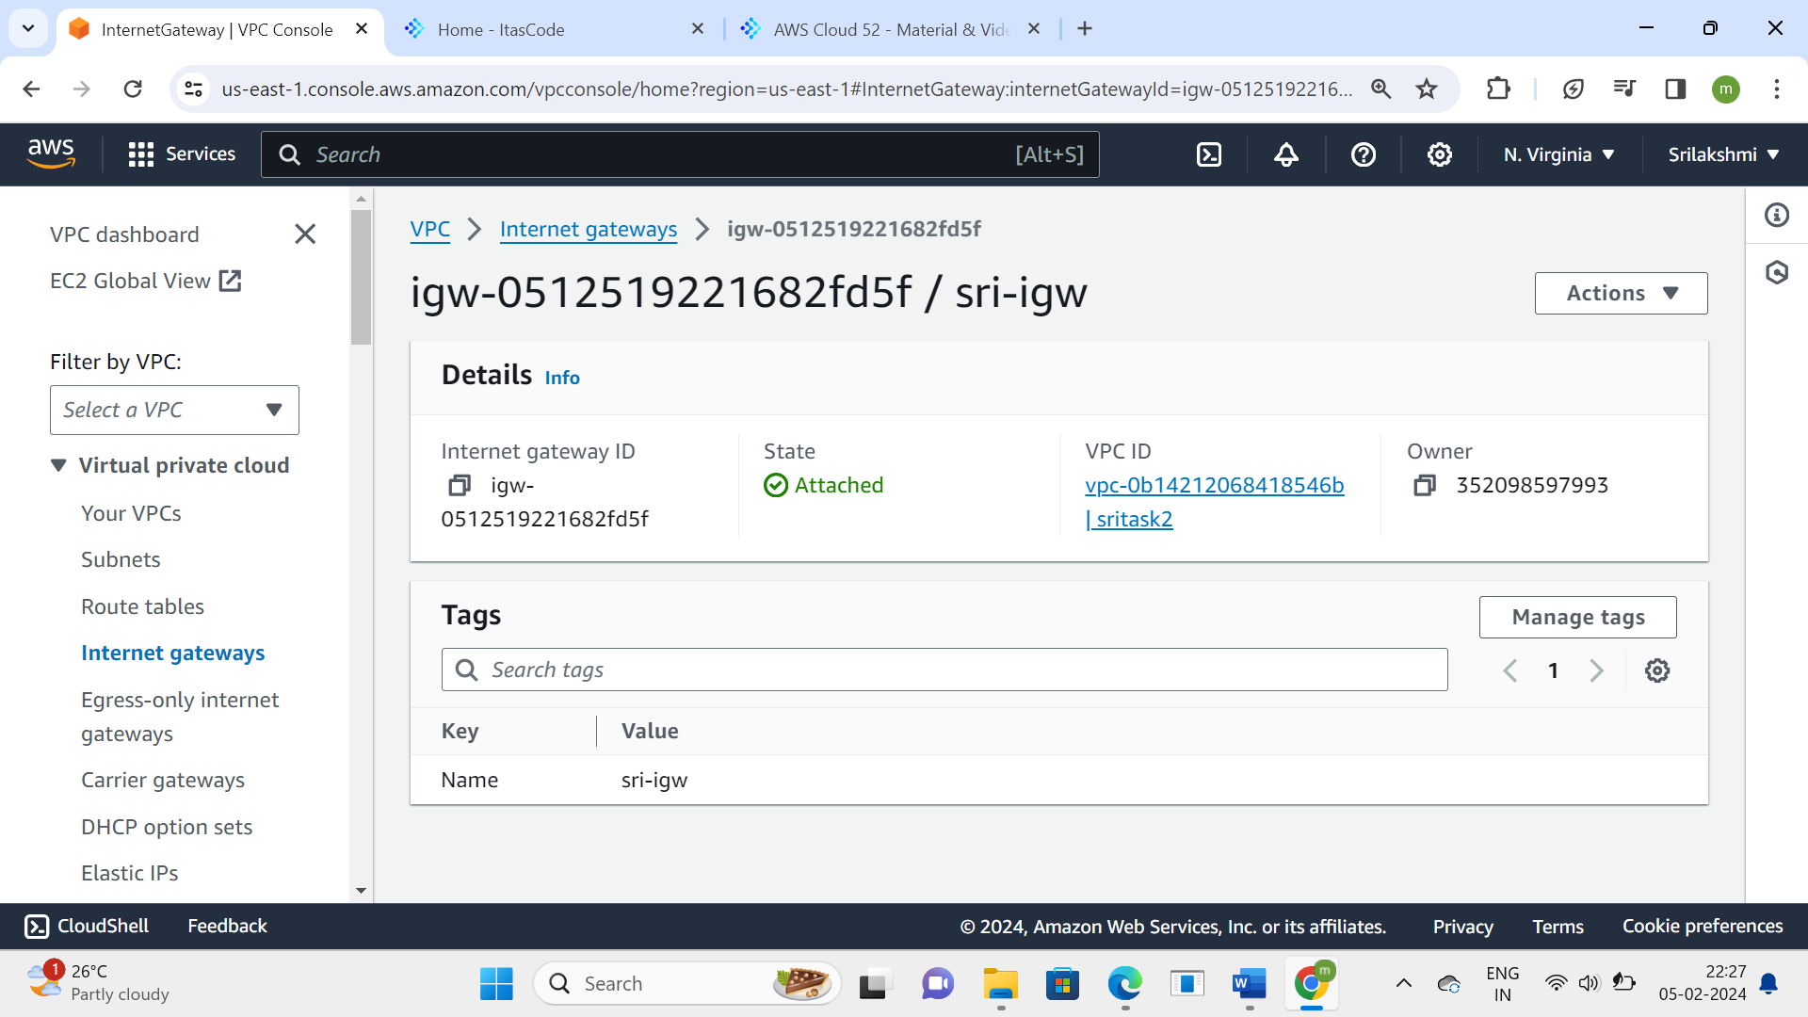

**Create route table to control the traffic flow , Name-sri-public-route**

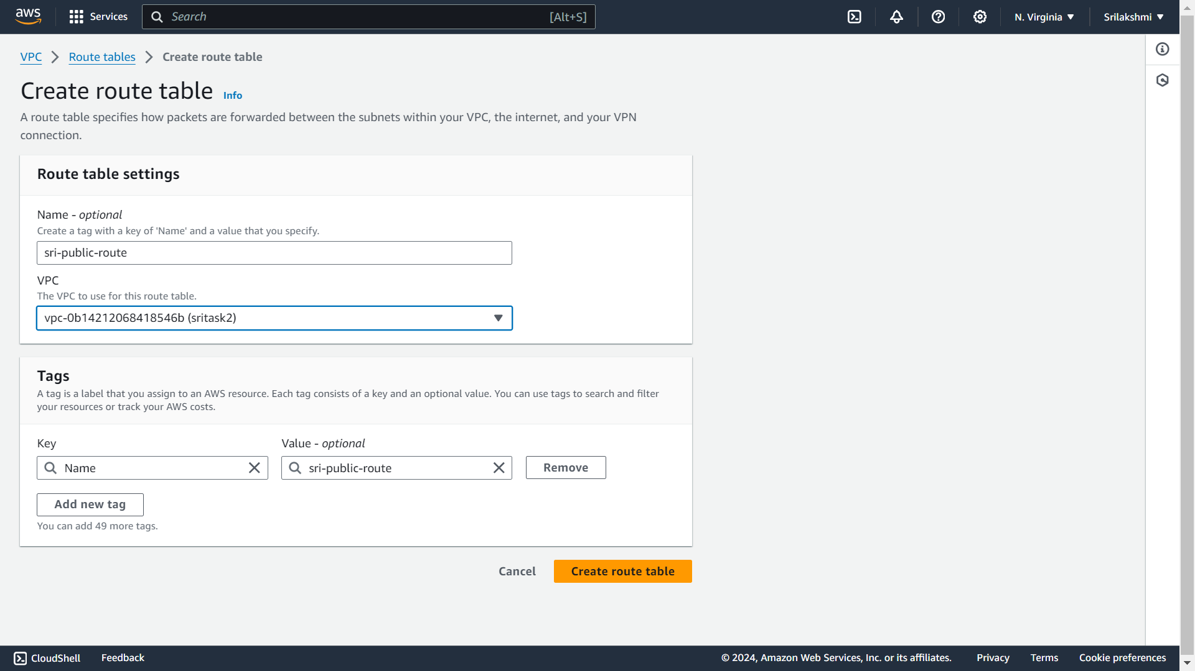

**Edit routes and click on save changes**

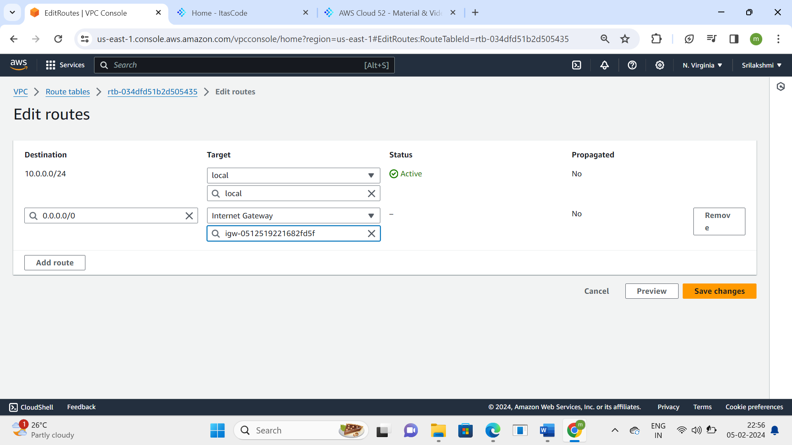

**Go to subnet associations and click on edit subnet associations**

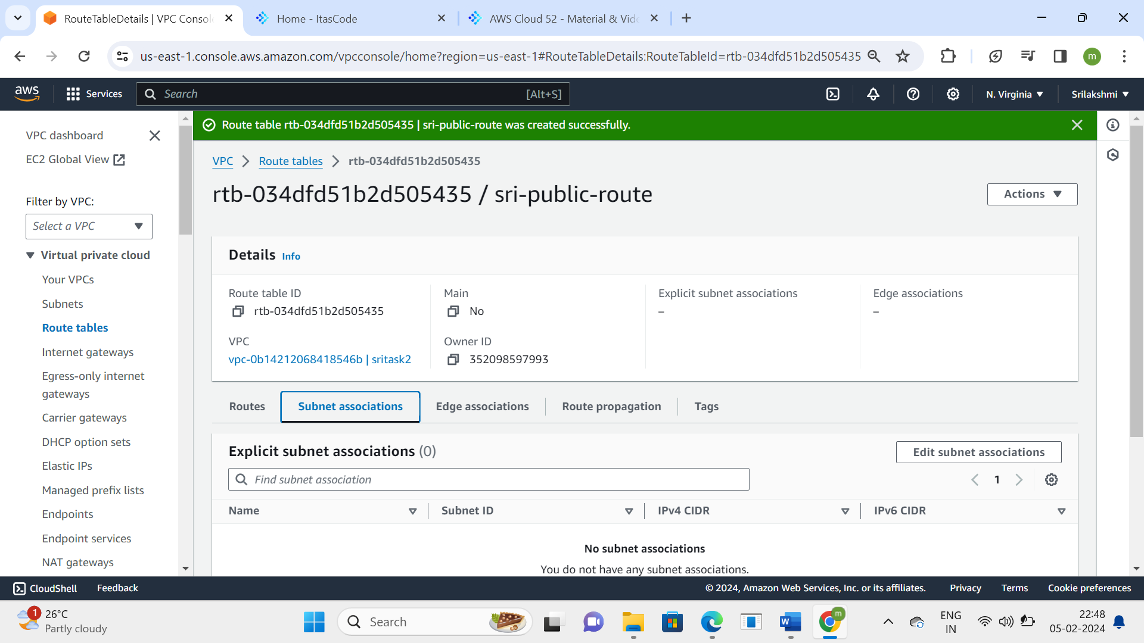

**Select available subnet and click on save associations**

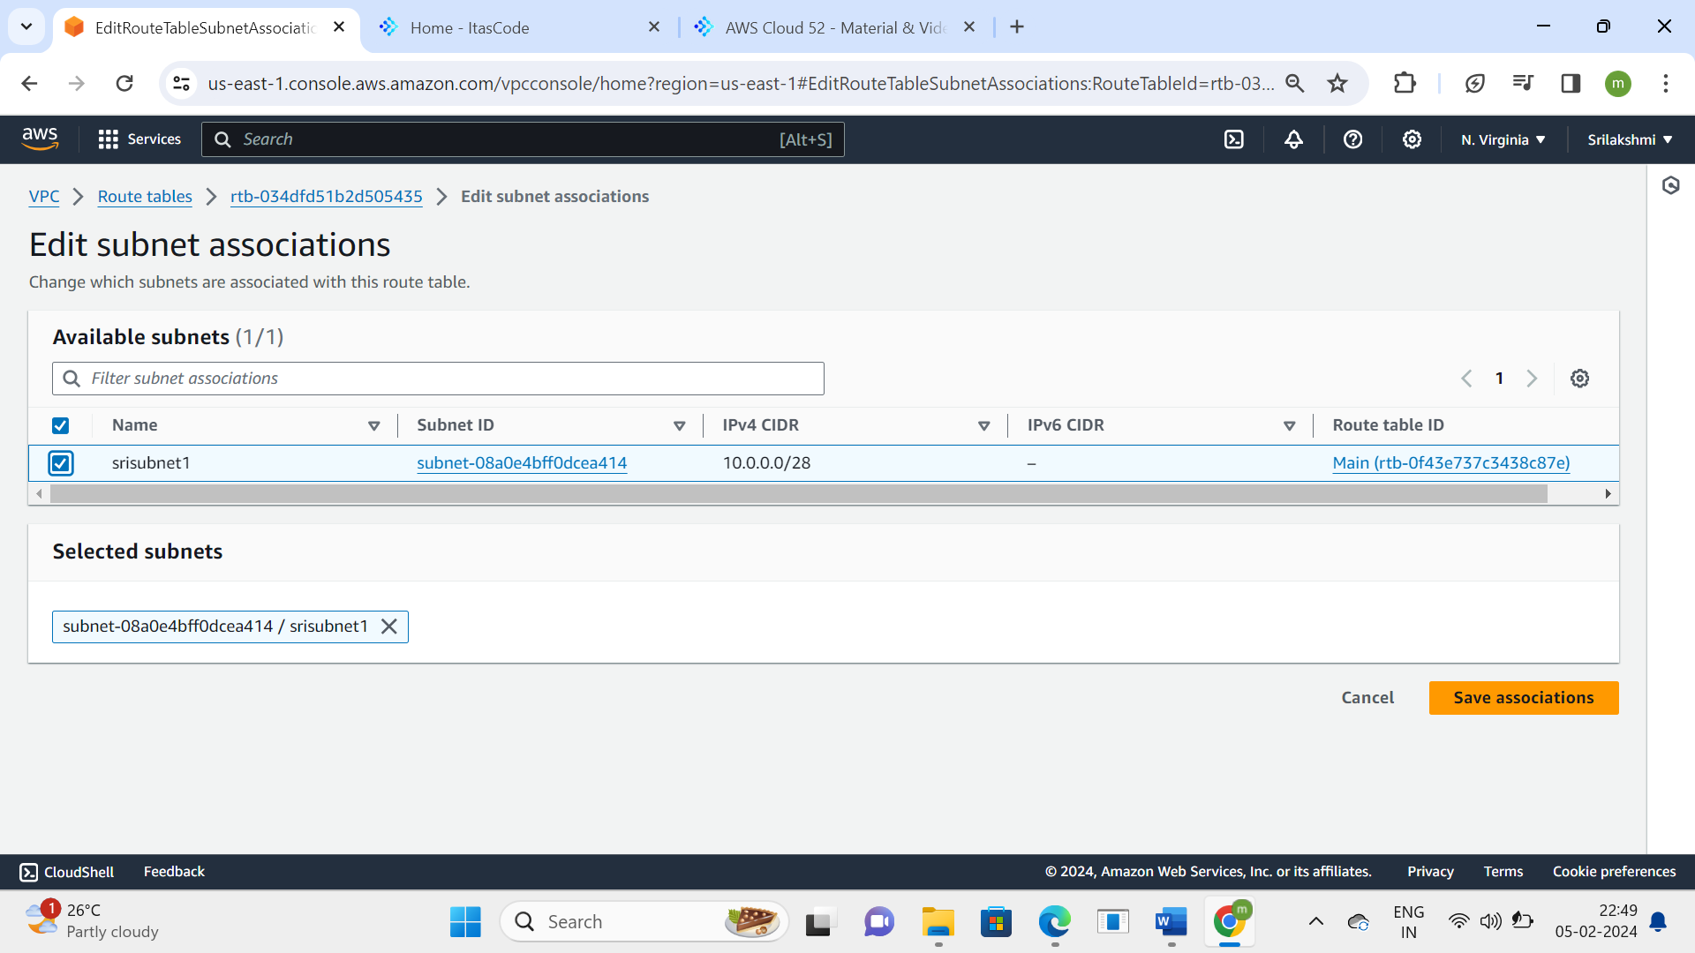

**The subnet association is created**

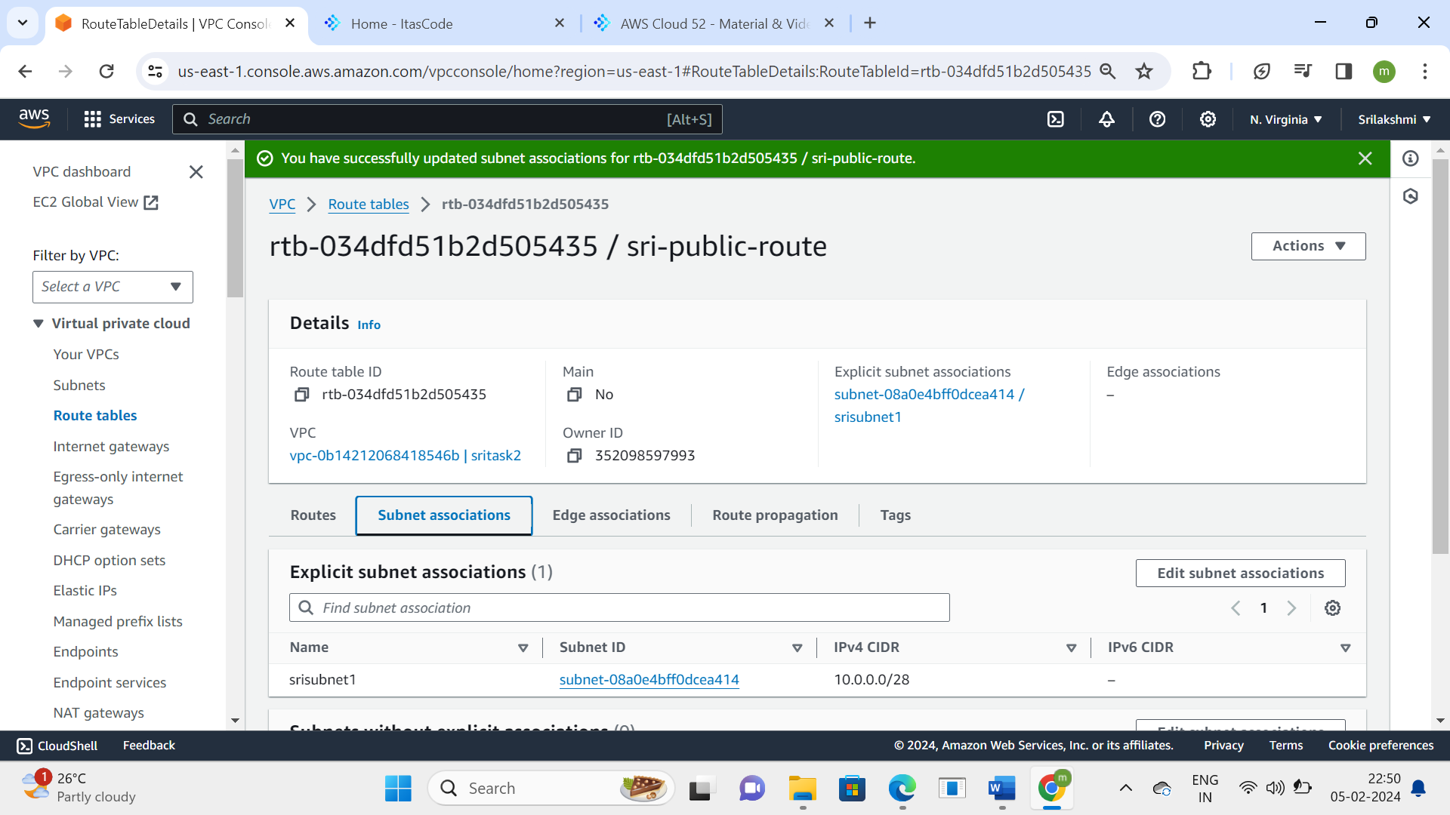

**Create security groups inbound and outbound rules**

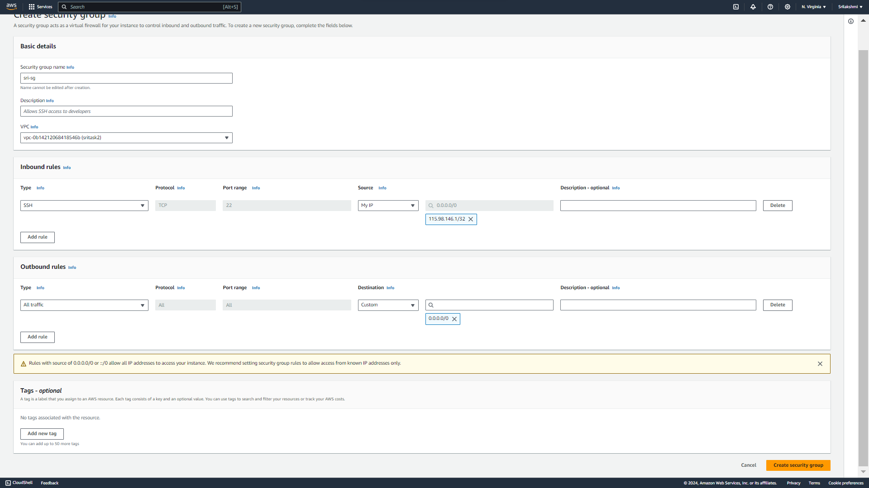

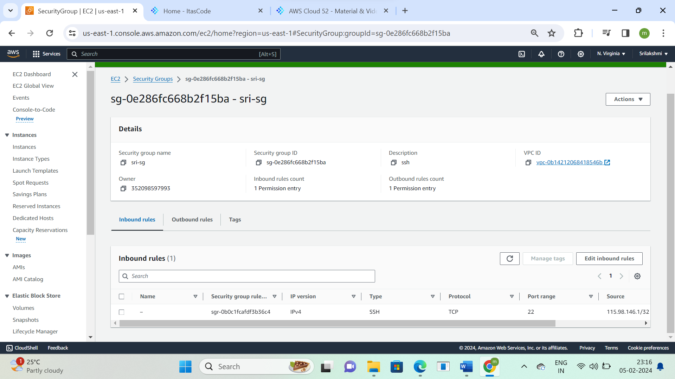

**This is the overview of VPC resource map**

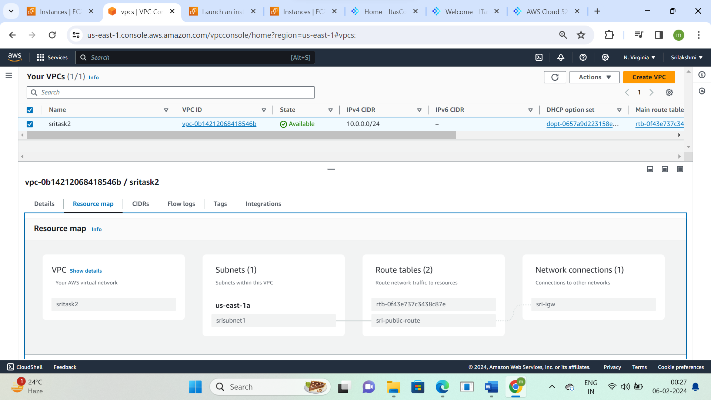

**Go to ec2 instance and launch instance with VPC networking settings**

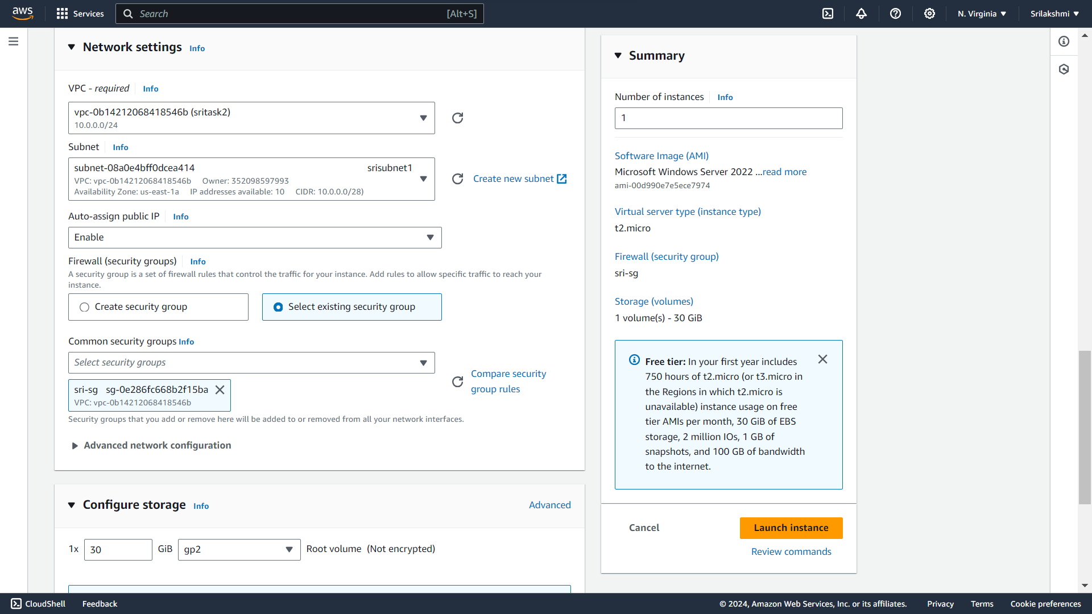

**Connect the server in rdp file**

